**Other works:** [https://drive.google.com/drive/folders/1w3E6wpb2khBGzqUUjZnOcaiLVOApTJVn?usp=sharing](https://drive.google.com/drive/folders/1w3E6wpb2khBGzqUUjZnOcaiLVOApTJVn?usp=sharing" \t "https://lms.hcmut.edu.vn/mod/page/_blank)

**Meet: https://www.youtube.com/watch?v=oC6YTrwKRDQ**

**Question 1:** Represent -24.12 in IEEE-754 format with the number of bits of the sign domain being 1 (0 if positive and 1 if negative), the exponent domain being 7, and the fraction domain being 8.

1 1000011 10000001

**Question 2:** What is the two's complement system? If the two's complement system has 8 bits, what are the largest and smallest numbers that can be represented?

- If the 2’s compliment system has 8 bits.

+ smallest num can be represented: -128 (1000 0000)

+ largest num can be represented: 127 (0111 1111)

smallest = 2^8-1-largest

**Question 3**: Given a set A={x, y, z, t, u, v} corresponding to the significant bits {2, 3, 5, 1, 0, 4}. Which string will the number x=33 represented by set A correspond to?

sorted A: {u, t, x, y, v, z} -> {0, 1, 2, 3, 4, 5}

-string: zu

**Question 4**: Suppose we have a data type A that can be represented by 10 bits. How many possible subsets of set A[<=3] (the set of ordered lists containing elements of data type A with a maximum size of 3) are there?

**Answer: unique elements is 2^10 = 1024**

**list of 0 elements is 1**

**list of 1 elements is 1024**

**list of 2 elements is 1024^2 = 1048576**

**list of 3 elements is 1024^3 = 1073741824**

**list of elements which is A <= 3 is 1+1024+1048576+1073741824 = 1074791425**

**The number of subsets of a set with n elements is 2^n**

**the numbers of subset A <= 3 = 2^1074791425**

**Question 5:** Infer the data type for the variables: a, b, c, x, y

def foo( a, b, c):

if c:

return a + b

return a

foo(x, 1, y)

a: int, float

b: int,

c: bool

x: same a

y: same c

**Question 6:** Write the equivalent code without reduction.

A = x == 2 ? y == z ? x : y : z;

if (x == 2) {

    if (y == z) {

        A = x;

    } else {

        A = y;

    }

} else {

    A = z;

}

**Question 7:** Represent the following expression in the order of pre, middle, and post:

( a + b ) - c * e + d / b * a

Knowing that +, - have the right associative property and *,/ have the left associative property.

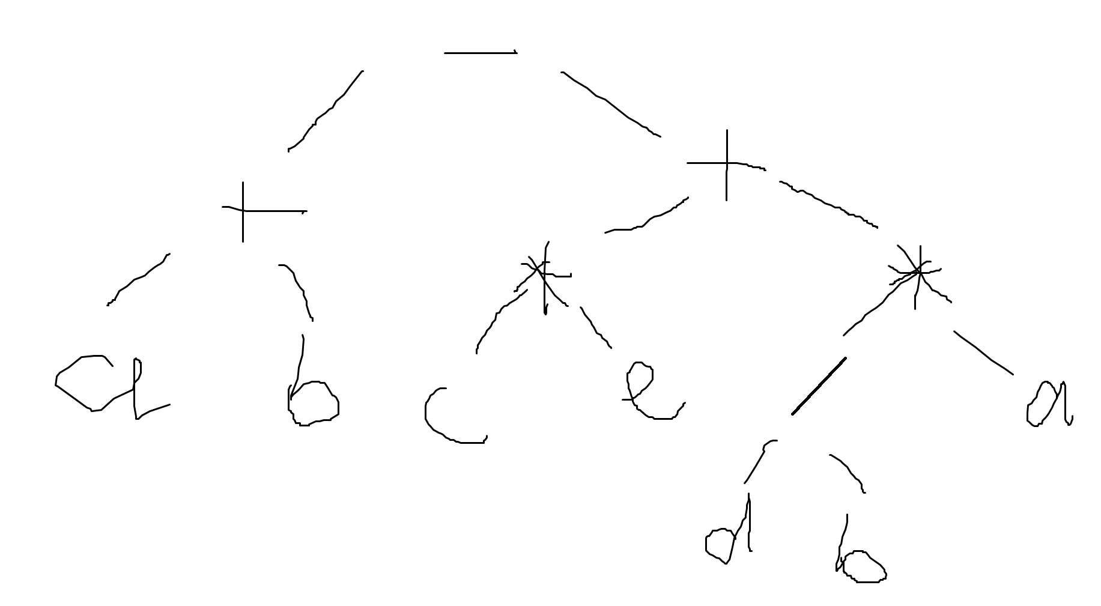

**Pre: - + a b + * c e * / d b a**

**In: ( a + b ) - (c * e + d / b * a)**

**Post: a b + c e * d b / a * + -**

**Question 8:** State the possible outcomes of the following expressions.

a – (b == 1)

a – (b = 1)

a + (a == 1)

a + (a=1)

(a = 1) || a

a – (b == 1) => a - 1 or a - 0

a – (b = 1)  => a - 1

a + (a == 1) =>  a+1  or  a+0

a + (a=1) => a + 1 or 1 + 1

 (a = 1) || a => return true or 1 for all cases.

**Question 9:** How does the *else* statement work in Python?

Else statement is activated whenever the boolean expression is false. This applied in if, while, for statements. Else does not activate when break.

```python

for i in range(5):

print(i)

else:

print("Loop completed normally")

```

```

0

1

2

3

4

Loop completed normally

```

```python

for i in range(5):

if i == 3:

     break

print(i)

else:

print("Loop completed normally")

```

```

0

1

2

```

```python

for i in range(5):

if i == 6:

     break

print(i)

else:

print("Loop completed normally")

```

```

0

1

2

3

4

Loop completed normally

```

**Question 10:** How does the *continue* statement work in *do…while* structure in C++?

While, do…while: Continue will stop that iteration and check the condition of the loop.

For: Continue will stop that iteration and go to the update expression of the for loop.